Project: Command-Line LLM API Assistant
Provider Used: Google Gemini (AI Studio)
1. Source Code Repository
http://github.com/Raheemullah-Wardag/Big-Brains-
2. Application Screenshots
Screenshot 1: The Source Code
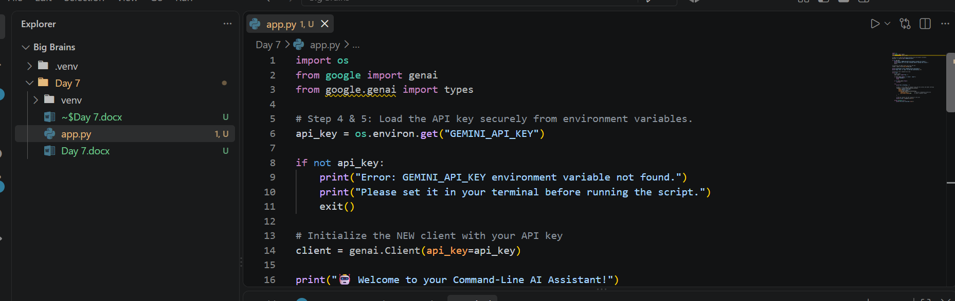
Screenshot 2: Successful API Request and Output
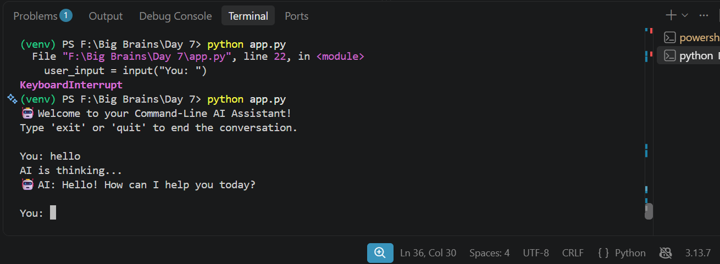
3. Explanation of the Request/Response Flow (Step 2 & 10)
Here is how the data moves through this application:
- User Input: The user types a question or instruction into the command-line terminal, which the Python script captures as a string variable.
- API Request: The Python script uses the google-generativeai library to package this text prompt, along with the securely stored API key and model settings (like temperature), into an HTTP request. This request is sent over the internet to Google's API servers.
- LLM Processing: Google's servers authenticate the request using the API key, then pass the text prompt to the Gemini model (gemini-1.5-flash). The model processes the instructions and generates a text response.
- API Response: Google's servers send the generated text back over the internet to the Python application.
- Application Output: The Python script receives the response object, extracts the text content, and prints it to the terminal for the user to read.

